

**Reducing the consumption of Single Use plastics in**

**South Ribble**

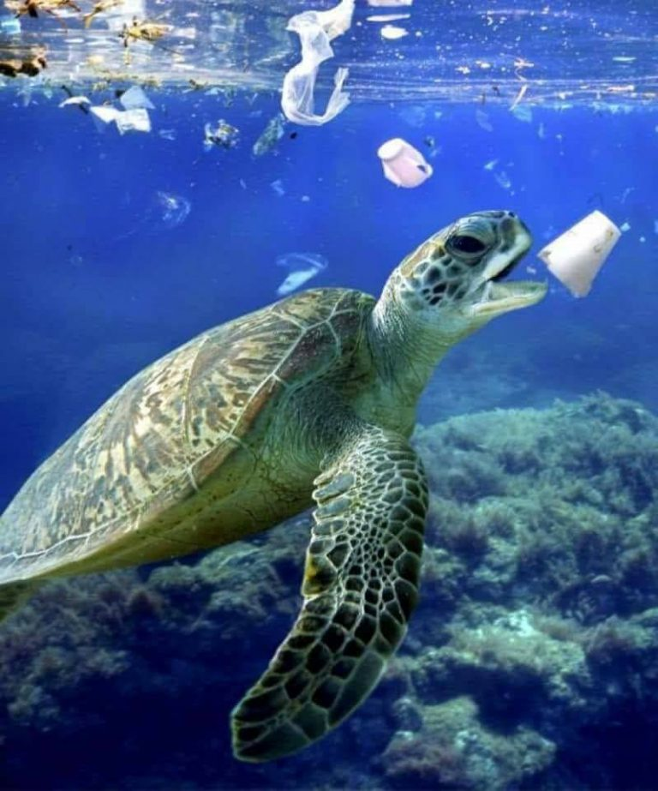

Single Use Plastics Strategy

# Background

In July 2019 a motion was submitted to the Full Council asking to declare a ‘Climate Emergency’ and to convene a task group to progress the goal of making South Ribble carbon neutral by 2030. Following the acceptance of the motion, declaration of the climate emergency and formation of the task group work has begun on a number of environmental initiatives, to help tackle the climate emergency facing us and achieve the Council’s goal of safeguarding our environment.

One of the first initiatives being addressed is the use of Single Use Plastics (SUP’s). According to recent research, eight million metric tons of plastic waste ends up in the world’s oceans each year, endangering marine life. There is also a growing understanding of the risks posed to human health and the wider food chain.

Public awareness of the problems caused by our throwaway society is at an all-time high and the Council needs to take action to promote the reduction of SUP’s.

This strategy will set out the South Ribble Borough Council’s policy and aims with regard to SUP’s within the borough minimising collection and disposal costs, reducing littering and improving the wider environment.



# Introduction

This strategy, sets out South Ribble Borough Council’s (SRBC) aims and objectives with regard to Single Use plastics (SUP’s)

### What are Single Use Plastics?

Single Use Plastics also known as disposable plastics, are commonly used for plastic packaging[1] and include items intended to be used only once before they are thrown away or recycled. These include, among other items, grocery bags, food packaging, bottles, straws, containers, cups and cutlery.

## The problem

At the end of its useful life a product or packaging is recycled, incinerated, landfilled, dumped in uncontrolled sites, or littered in the environment. According to recent estimates[2], 79% of the plastic waste ever produced now sits in landfills, dumps or in the environment, while about 12% has been incinerated and only 9% has been recycled.

*"It is estimated that 8.3 billion tonnes of plastic have been produced since the 1950s.*

*Without urgent action to cut demand, this is likely to be 34 billion tonnes by 2050, the majority of which will end up in landfill or polluting the world’s continents and oceans"*

Source: Government's 25 Year Environment Plan

Plastics are a complex mixture of various chemicals, predominantly and for the focus of this report fossil-derived, although a growing number of biogenic sourced plastics are being developed. Plastics, which do not biodegrade but photodegrade, meaning they slowly break down into small fragments are known as micro-plastics.

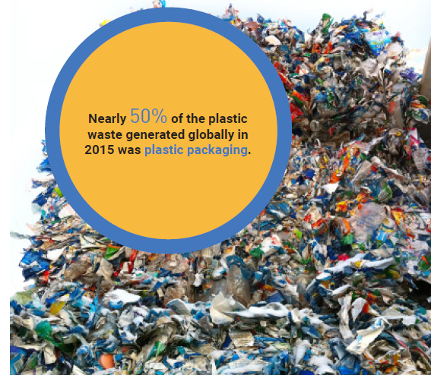

During the break down of plastic, toxic chemicals used in their formation are released into the environment. These pass into water supplies, rivers and seas, and through farmland, where they are absorbed by plants and animals, and thus enter the food chain which includes the human food chain.

Studies in Vienna have identified plastic waste in the digestive tract of humans from eight different countries including the UK.

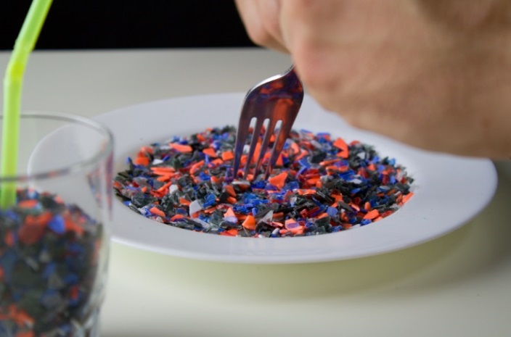**We are eating our own Waste!**

Current situation

Plastics generally, and in particular SUP’s are currently wide spread. They contain a number of different types of plastics, especially in the food industry. Not all of these are recyclable and the wide range of different plastics makes collection, sorting and treatment, including recycling, expensive and energy intensive.

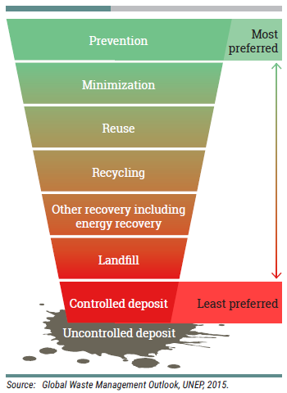

The Council, in-line with most of the country carries out the collection of recyclable material, however until very recently many plastics were not collected or sent for recycling and would have been landfilled e.g. yoghurt pots and food packaging.

The prevailing problems associated with the use of plastics need to be addressed in order to protect the planet, environment and our own health. The internationally recognised waste hierarchy highlights that waste prevention is the most favourable option, with reuse and recycling following behind.

SUP’s go against this hierarchy, encouraging the least preferred options of waste disposal.

South Ribble Borough Council are committed through its statutory and morale roles within the community to prevent, reduce, reuse and recycle as much waste including SUP’s as possible in all our activities. As part of this approach this strategy sets out the measures that the Council will be taking to prevent the use of SUP’s within our own activities and how we will use the influence of the council to educate and encourage others to follow suit.

The council must first lead by example

The UK government have made a start on reducing the prevalence of SUP’s in our environment following the introduction of the 5p bag charge. Within the first year following the introduction of the charge the use of SUP’s bags fell by 85%.

Other countries have gone further with the introduction of Extended Producer Responsibility (EPR), helping to develop new technologies and creating jobs in the recycling market. Some countries have effectively banned certain plastics and reduced the types of plastic packaging to a small number of plastics enabling easier collection, sorting and recycling of those used.

Deposit Return Schemes (DRS) have also proven effective in reducing litter and increasing reuse of plastic products. DRS leave a charge on plastic products as a deposit which is returned to the customer when the packaging is brought back to the store for re-use.

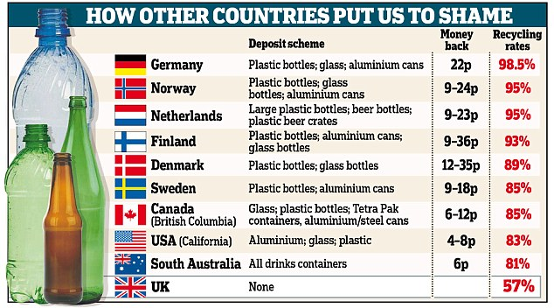

Daily Mail On-line, 14th February 2017, by Daniel martin and Sean Poulter

# Policy context

Since 1975, the EU has been introducing laws to help minimise the harmful effects of waste and encourage Europeans to conserve natural resources. This has driven waste-management legislation and practices in the United Kingdom, and every other EU member state.

It is the UK Government’s policy that the UK will remain bound by existing EU environmental law, subject to possible future review, but this is not legally straightforward. There is currently no clarity as to what status Commission guidance will have post-Brexit.

The European Waste Framework Directive came into force in December 2010. It focuses on waste prevention and on turning EU member states into societies that recycle waste.

In December 2017, 193 members of the UN signed a resolution committing to prevent and significantly reduce marine pollution of all kinds by 2025 and to prioritise policies and measures to avoid marine litter and micro-plastics entering the marine environment.

The EU Strategy for Plastics in a Circular Economy was adopted in January 2018. It intends to transform the way plastic products are designed, used, produced and recycled in order to reduce the value of plastic that is lost from the economy each year after a very short use.

In July 2019 South Ribble Borough Council declared a Climate Emergency, highlighting the potentially damaging effects of climate change on the health and well-being of our residents. The declaration seeks to minimise carbon emissions into the environment and generally protect, improve and minimise our impact on the environment.

# The Strategy

This strategy will be managed and monitored through the Climate Emergency Task Group. They will review the progress made to achieving the following aims and objectives and provide reports on the progress made and difficulties encountered to Cabinet and the Leadership Team.

The most common single-use plastics found in the environment, in order of magnitude are; cigarette butts, plastic drinking bottles, plastic bottle caps, food wrappers, plastic grocery bags, plastic lids, straws and stirrers, other types of plastic bags, and foam take-away containers.

The Council recognises that discarded plastics, including non-recyclable cups, bottles and straws, are a major environmental pollutant and of detrimental impact to South Ribble Borough and its communities.

Four key themes have been identified which need to be addressed to meaningfully reduce the volume of SUP’s consumed across our Borough:

* Getting our own house in order;
* Working with suppliers and contractors;
* Helping raise awareness across the Borough;
* Enabling South Ribble to take action.

Action should be taken in line with the national waste hierarchy as detailed above.

# Aims and Objectives

## Aims

South Ribble Borough Council aims to prevent the use of Single Use Plastics with all Council operations both direct and in-direct, and to be a ‘single-use-plastic free’ authority by March 2025, with a minimum 85% reduction by March 2021.

Encourage partner organisations to follow suit and prevent the use of SUP’s within their businesses.

Encourage South Ribble Businesses to stop using SUP’s.

Promotion of the SUP’s initiative among staff, Members, and the public to reduce their consumption of SUP’s.

## Objectives

Ending the sale and provision of all SUP’s products such as bottles, straws and disposable cups at all council buildings and sponsored events by March 2020.

Undertake a full audit of council operations to identify where SUP’s are consumed by the Council by March 2020.

To identify alternatives to the use of SUP’s and complete a financial and environmental impact assessment on the procurement of alternatives.

To embed within all supplier contracts that no SUP’s will be used within work undertaken for the Council, (with some basic exceptions).

To produce educational material for staff, members, schools, businesses and the general public to encourage the reduction in use of SUP’s.

To work with large manufacturers to reduce SUP’s consumption, particularly with regard to packaging.

# Things to Consider

## Life Cycle Thinking

The current debate around waste plastics has focussed on the impacts on marine pollution and has brought some people to question the long-term viability of a single-use throwaway society. However, some of the alternatives to single use plastics may be more impactful on climate change. Considering using alternatives such as non-plastics and reusable containers can result in counterintuitive consequences.

Life Cycle Thinking will be essential to ensure that reusable replacement products don’t have a greater environmental impact than disposable alternatives. By considering all stages of a product’s lifespan, including extraction of raw materials, construction, use and disposal, we can ensure that measures taken at one stage do not lead to unintended consequences in another.

For example, results from life cycle assessments suggest that:

* Cotton bags need to be used 173 times before they become more environmentally friendly than a single use plastic bag;
* Paper bags can decompose but have a higher carbon footprint than plastic ones, because the process of making them uses more energy; and
* A stainless steel water bottle needs to be used several hundred times before it is better for the environment than a single-use plastic one.

## Compostable items

In many sites, compostable plastics have been seen to be a good alternative to SUP’s. However, compostable plastics tend to exhibit similar aesthetic and physical properties as non-compostable plastics meaning that they are almost impossible to distinguish at a composting plant. There is no way for plant operators to determine whether they should be accepted in the process or screened out as contamination. Conversely, this same confusion arises at plastics recycling facilities which cannot differentiate between compostable and mainstream target plastic types.

A key limitation of compostable plastics is that a period of six months is required to break down the material. This is unlikely to be realistic for composting facilities in the UK which typically process material over an eight to twelve-week period.

In principle, compostable cups appear to be environmentally preferable. However, under current arrangements it is likely that the majority of compostable cups end up in landfill where their breakdown produces methane, a greenhouse gas 25 times more damaging than carbon dioxide.

In light of the above, it is recommended that focusing on waste prevention via reuse as the preferred option for cups. If the Council opts to use compostable items, then the only way to ensure these are correctly disposed of is to have suitable compostable facilities onsite or nearby, Windrows, typically utilised for green waste are not suitable.

Key Actions

The council is conscious of the environmental impact of SUP’s on the local environment and world ecosystem and will endeavour to reduce the use of SUP’s throughout its operations.

## Internal Audit

One of the key problems in respect of SUP’s is that we don’t know the scale of the issue. An audit of the Council’s SUP’s items and packaging is required to understand the level of consumption across the Council estate. Once we have a baseline of SUP’s consumption, it will become much easier to set annual targets going forward.

The Climate Emergency Task Group will undertake a full Council wide audit on the use of SUP’s. This is to be completed by the end of June 2020, subject to the provision of suitable staffing resources. This will include the identification and potential financial implications of alternative products.

## Sale of Single Use Plastics

The Council will work to prevent the sale of SUP’s over its full operations. Quick wins, e.g. plastic bottles, plastic cups, straws will be implemented in the shortest time possible.

## Internal Staff Promotion

The Task Group will develop an internal educational program to inform staff of the harmful impacts from SUP’s, and to encourage and provide information on alternative options.

## Use of Single Use Plastics at Council events

The Council will discourage the use of SUP’s at Council held events with a view to ultimately banning their use. Given the availability of alternative products this may be on a product by product basis. For example starting with plastic cups, straws and balloon holders.

## External Promotion

The Task Group will develop an educational and promotional campaign to discourage the use of SUP’s by the general public and businesses within South Ribble.

## Stakeholders & Providers

The task Group will identify Stakeholders and providers of services to the council and will encourage them to seek alternatives to SUP’s.

The task group will investigate the potential for including clauses within the contracts to restrict, and where feasible, prevent the use of SUP’s.

The task Group will encourage Council Tenants to seek alternatives to SUP’s.

### Large manufactures

As detailed above the majority of SUP’s is in the form of packaging, within South Ribble there are a number of large manufacturing companies which will utilise a significant amount of packaging within their products.

The task group will specifically contact these large distributors and manufactures to discuss and encourage the use of alternative packaging options to prevent the prevalence of SUP’s within the industry.

1. GESAMP, 2015a
2. Geyer, Jambeck, and Law, 2017

   https://www.theguardian.com/commentisfree/2018/oct/23/humans-contain-plastic-waste-drastic-banning-straws